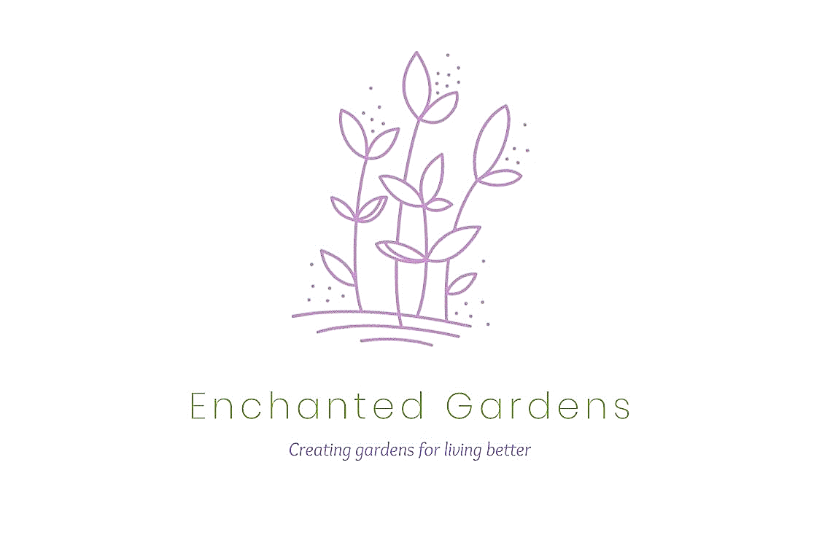
Enchanted Gardens Design
Client Questionnaire
Creative Garden Design for Inspired Outdoor Spaces

💡 How to Complete This Form:
Please answer the following questions to help us understand your needs. The more details you provide, the better we can create a design that suits your space and style.
📩 Once completed, email it to enchantedgardensdesign@gmail.com along with 2-3 photos of your garden, or more if there are specific issues you’d like us to see.

1. Your Contact Details
📍 Name & Surname:
📍 Address & Postcode:
📍 Email Address:
📍 Phone Number:

2. Your Garden & Goals
✅ What is the approximate size of your garden? (Length × Width in metres)
✅ What would you like to improve in your garden? (E.g., more colour, lower maintenance, a seating area, better pathways.)
✅ Do you have a budget in mind? (This helps us tailor the design to your needs. Our design fees start at £750, depending on garden size and complexity. See our pricing page for details.) Please state your budget here:

✅ 📸 Please attach 2-3 photos of your garden to the email (including one wide-angle view).

3. Your Garden Style & Use
💡 What style appeals to you? (Check (x) as many as you like – click on the box)
☐ Formal
☐ Cottage
☐ Modern / Architectural
☐ Oriental
☐ Rustic
☐ Prairie / Naturalistic
☐ Other:

🎭 What do you want to use your garden for? (Tick all that apply)
☐ Relaxing / Sitting
☐ Entertaining
☐ Growing vegetables / herbs
☐ Children’s play area
☐ Space for pets
☐ Other: (Explain here)

4. Maintenance & Practical Needs
🧑‍🌾 How much maintenance do you prefer?
☐ Low (minimal upkeep, easy plants)
☐ Medium (regular pruning & care)
☐ High (happy to maintain intricate plants)
🏡 Any functional issues we should solve? ((E.g., privacy from neighbours, difficult access, waterlogged areas? If drainage is a major issue, a specialist may be required.)

5. Special Requests
🌱 Any favourite plants, colours, or features?
🌿 Any plants or colours you dislike?
🏡 Any specific materials you like for paving, fencing, or walls?

6. Anything else you'd like to tell us?
(Feel free to mention special requests, accessibility needs, or any future plans for your garden.)

📩 Email this form with your garden photos to enchantedgardensdesign@gmail.com.

Thank you! We look forward to designing your dream garden!

